**Assignment 2**

Ardelean Octavian

30432

Requirement: Design and implement a system based on a message broker middleware that gathers data from the sensors, pre-processes the data and then stores data into the database to the corresponding patient. If the queue consumer application that preprocesses the data detects an anomalous activity according to the following set of rules, it asynchronously notifies the caregiver application that a patient has problems:¬R1: The sleep period longer than 12 hours;¬R2: The leaving activity (outdoor) is longer than 12 hours;¬R3: The period spent in bathroom is longer than 1 hour;

Conceptual diagram

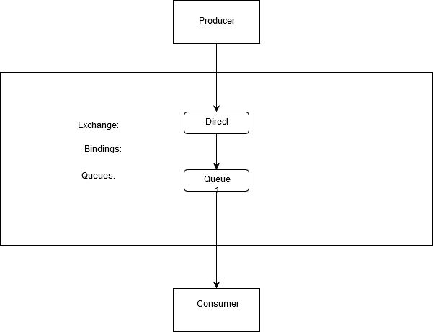

In our case, the producer/sender will be our Send app, Consumer will be our HospitalApp and the broker will be RabbitMQ.

Data will be transmited in a direct manner (in contrast to a fanout exchange) because in our case we don’t have multiple clients accessing the app.

Deployment diagram

